Project Synopsis

Title: Face Detection and Recognition by Computer Vision.

Performed By: Adnan Ashfaque Ahmed.

Class: Second Year

Department: Computer Engineering.

Email: [adnanahmed.indian@gmail.com](mailto:adnanahmed.indian@gmail.com)

Phone no: 7350170156

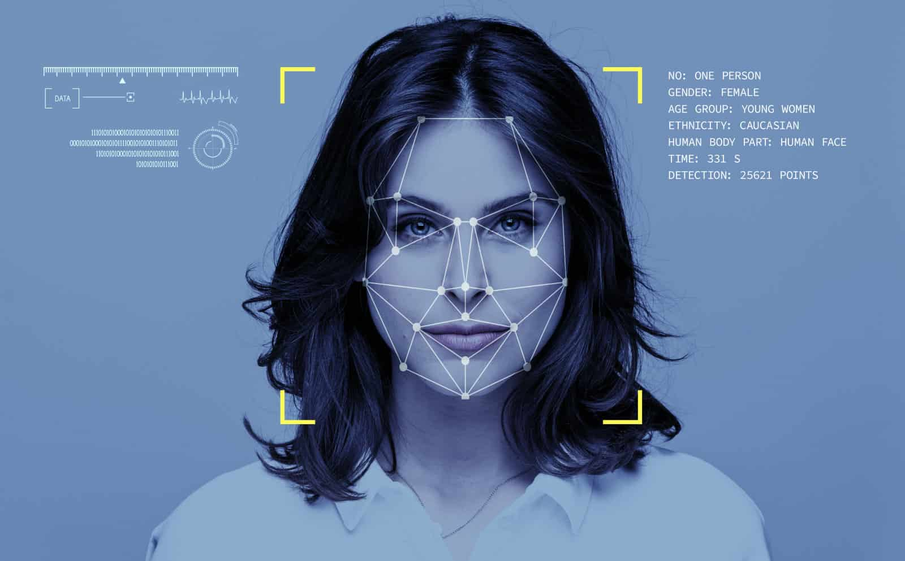

Introduction:

Today Computers are smart enough for facial recognition of human. Taking advantage of Computer Vision, this project would be able to detect human face and recognize them. Our project is divided in two parts, the first is to detect the face and second to recognize it. Project uses machine learning and computer learns the faces of people by training and applies its knowledge to recognize a face which it has seen before.

Dependencies:

1. Language: Python
2. Modules: OpenCv

Work On:

Face Detection:

Project uses HAAR classifier to detect faces. The Haar Classifier is a machine learning based approach. Haar Classifiers extracts Haar features from each image. Windows are placed on the picture to calculate a single feature. This feature is a single value obtained by subtracting the sum of pixels under the white part of the window from the sum of the pixels under the black part of the window.

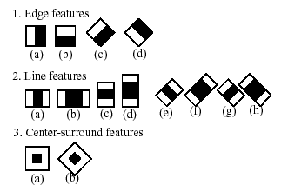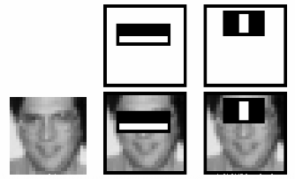

The Haar Classifier extracts two features here. Like the region of eyes is darker than skin region just below eyes. Also, the region of nose bone is darker than eyes. This way it checks and matches features of face, to detect if it is human face or not.

Face Recognition:

Project uses Local binary patterns histograms (LBPH) Face Recognizer. It takes a 3×3 window and move it across one image. At each move (each local part of the picture), compare the pixel at the center, with its surrounding pixels. Denote the neighbors with intensity value less than or equal to the center pixel by 1 and the rest by 0. After reading these 0/1 values under the 3×3 window in a clockwise order, we get binary pattern like 11100011 that is local to a particular area of the picture. Multiple binary patterns will be achieved for multiple areas. Converting these binaries to decimal. A histogram is plotted

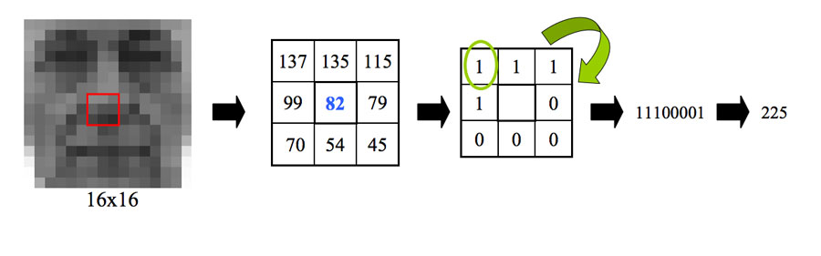

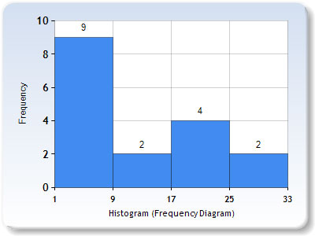

Thus, we get a histogram for each image and for each part/feature of it, and for multiple images of same person there will be multiple histograms, which will help in recognizing person.

Work Plan:

Step 1. Data Gathering:

Gathering a good number of images of people whose face to be recognized. Images should be from be different angles and different looks. This will be Training Data.

Step 2. Train Face Recognizer:

Train OpenCV's LBPH recognizer by feeding it the data we prepared in step 1.

Step 3: Testing:

Test the model with some new images of the people it is trained with.

Benefits & Limitations:

Benefits:

1. Haar Classifier shows accurate results while detecting face with low false positive rates.
2. LBPH is not affected by lighting conditions, as it compares pixels with neighboring pixels, thus things are relative.

Limitations:

1. Results may not be accurate if training data is less.
2. Results may not be accurate if training images are of different sizes.

References:

1. <https://www.youtube.com/watch?v=-ZrDjwXZGxI&t=2s>
2. <https://www.youtube.com/watch?v=PmZ29Vta7Vc&t=2774s>
3. <https://www.youtube.com/watch?v=wpAwdsubl1w>
4. <https://www.youtube.com/watch?v=h-z9-bMtd7w>
5. <https://towardsdatascience.com/face-recognition-how-lbph-works-90ec258c3d6b>
6. <https://towardsdatascience.com/face-detection-for-beginners-e58e8f21aad9>
7. <https://towardsdatascience.com/real-time-face-recognition-with-cpu-983d35cc3ec5>
8. <https://www.superdatascience.com/blogs/opencv-face-recognition>
9. <https://www.superdatascience.com/blogs/opencv-face-detection/>
10. <https://stackoverflow.com/>

Conclusion:

Successful Face detection and recognition can be done with OpenCv libraries by training data. There are more advanced methods like deep learning, keras to do same with more accurately. These models can enough to be applied for real life applications like face recognition, security purposes and so on.